Java Sample Review Questions for Modules
- Fundamentals of Object Oriented with Java
- Advanced Java
- Web Services
Note: The provided are Sample Answers and reflect latest java versions
Sample Easy and Medium Questions
- What is a web Service?
Sample Answer:
A Web service is the type of internet software that uses standardized messaging protocol over the distributed environment.
A Web service can also be defined as a self-contained, self-describing, modular application, based on XML/JSON that can be published to and invoked from the Web.

- Which type of web services is strict on message exchange format and what is that format?
Answer:
The service which is strict on message exchange format is SOAP.
The format is XML(eXtensible Markup Language)
- All web services are APIs, but not all APIs are web services.
- Yes
- No
Sample Answer:
- Yes
- Explain the meaning of the following in RESTful services.
  - POST /employees
  - GET /employees
  - DELETE /employees
  - PUT / employees/{id}
Sample Answer:
POST /employees Create a new employee
GET /employees/{id}: Retrieve or read the details of one employee with id provided
GET /employees: Retrieve all the employees
DELETE /employees : Delete all the employees
PUT / employees/{id}: Update the employee with the ID provided
- Explain advantages of using JPQL instead of native SQL.
Sample Answer:
A Native query is a SQL statement that is specific to a particular database (e.g. MySQL), which differs slightly from JPQL which is used by Spring Data JPA by default.
- Differentiate authentication and authorization?
Answer:
Authentication is the process of ascertaining that somebody really is who he claims to be.
Authorization refers to rules that determine who is allowed to do what. E.g. Adam may be authorized to create and delete databases, while Usama is only authorized to read.
Or:
Authentication = login + password (who you are)
Authorization = permissions (what you are allowed to do)
Also:
Authentication = Verification
Authorization = Permissions

- Explain the Service definition
Sample Answer:
is the contract between the service provider and service consumers. Service definition defines the format of request and response, request structure, response structure, and endpoint.

- Explain XSD in SOAP services development?
Sample Answer:
XSD is an XML Schema commonly known as XML Schema Definition (XSD). It is used to describe and validate the structure and the content of XML data.
- What is the error in the following line of XML code.
<address> Nyabihu RN4</Address>
Sample Answer:
The closing tag is not the same as the starting tag. This is an error because XML is case-sensitive.
- Differentiate JPQL and native SQL.
Sample Answer:
A Native SQL is a SQL statement that is specific to a particular database (e.g. MySQL), which differs slightly from JPQL which is used by Spring Data JPA by default.
- What is maven and at least 2 of its benefits?
Sample Answer:
open-source software project management tool for Building and manage dependencies of Java apps and managing applications.

- Explain Hibernate?

Sample Answer:
Hibernate is the implementation of JPA. It is the most popular ORM framework, while JPA is an API that defines the specification.

Key features of JPA:
- JPA is only a specification, it is not an implementation.
- It is a set of rules and guidelines to set interfaces for implementing object-relational mapping .
- It needs a few classes and interfaces.
- It supports simple, cleaner, and assimilated object-relational mapping.
- It supports polymorphism and inheritance.
- Dynamic and named queries can be included in JPA.
The Key feature of Hibernate is to map the Java classes to database tables :
- Hibernate is an implementation of JPA guidelines.
- It helps in mapping Java data types to SQL data types.
- It is the contributor of JPA

JPA vs. Hibernate
JPA | Hibernate
Java Persistence API (JPA) defines the management of relational data in Java applications. | Hibernate is an Object-Relational Mapping (ORM) tool which is used to save the state of Java objects into the database.
It is just a specification. Various ORM tools implement it for data persistence. | It is one of the most frequently used JPA implementations.
It is defined in the jakarta.persistence package. | It is defined in the org.hibernate package.
The EntityManagerFactory interface is used to interact with the entity manager factory for the persistence unit. Thus, it provides an entity manager. | It uses SessionFactory interface to create Session instances.
It uses EntityManager interface to create, read, and delete operations for instances of mapped entity classes. This interface interacts with the persistence context. | It uses Session interface to create, read, and delete operations for instances of mapped entity classes. It behaves as a runtime interface between a Java application and Hibernate.
It uses Java Persistence Query Language (JPQL) as an object-oriented query language to perform database operations. | It uses Hibernate Query Language (HQL) as an object-oriented query language to perform database operations.

- Identify at least two interfaces that can be extended when creating a repository.
Answers:
JpaRepository
ListPagingAndSortingRepository
ListCrudRepository
Also you can still use
CrudRepository
PagingAndSortingRepository
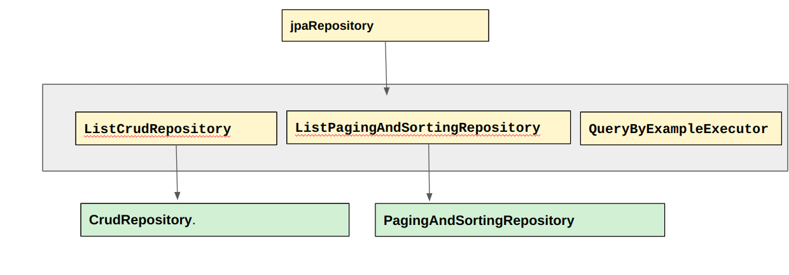
Picture: Spring Data 3.0
- REST stands for representational State Transport. .
- Yes
- No
Answer:
b)No

- Using API tools like postman, generate the body of the endpoint in JSON required to test the saving of a employee identified by id:integer, lastname:string, firstname:string, email:string:gender:string and dob:Date.
Sample Answer:
{
"id": "1",
"lastname": "Ange",
"firstname": "Mugisha",
"email": "amugisha@domain.com",
"gender": "Male",
"dob": "2000-02-30"
}
- Explain the following status code in web services Development when an API is called.
STATUS CODE | DESCRIPTION
401
404

Sample Answer:

STATUS CODE | DESCRIPTION
401 | UNAUTHORISED
404 | RESOURCE NOT FOUND

- Differentiate @RequestParam and @PathVariable Spring Boot Annotations.
Sample Answer:
@RequestParam: It is used to extract the query parameters form the URL
@PathVariable: It is used to extract the values from the URI. It is most suitable for the RESTful web service, where the URL contains a path variable.
- What is a Request and Response in web services development?

Answer:
Request is the input to a web service, and the response is the output from a web service.

- Give two(2) examples of Checked exceptions and two(2) examples of unchecked exceptions in Java of your choice.

Examples of Checked Exceptions:
IOException
FileNotFoundException
Some Examples of Unchecked Exceptions( FROM RuntimeException)
ArithmeticException
ArrayIndexOutOfBoundException
NullPointerException

- what is the output of the following block of codes? Explain your answer.
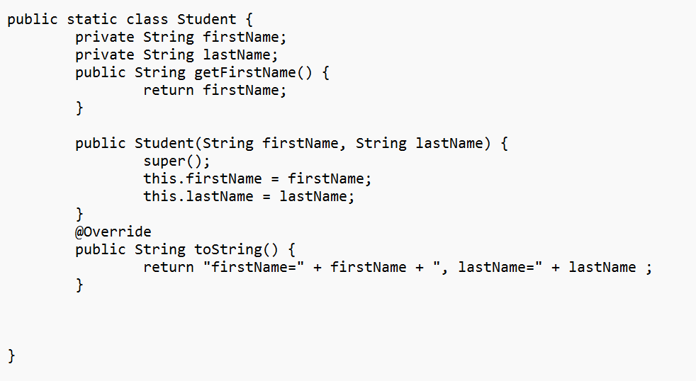
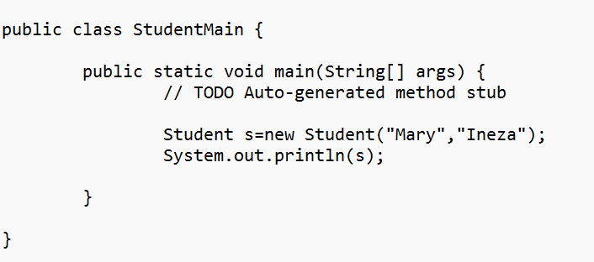
Answer: error, student class is static, static keyword is not allowed for outer class and mainly as mentioned above static can’t be used at Package level. It only used within the Class level
- Briefly discuss the main method in java
Sample Answer:
A main() method in java is an entry point to start the execution of a program. Every Java application has at least one class and at least one main method. Normally, an application consists of many classes and only one of the class needs to have a main method
- Discuss Dependency Injection in spring framework
Sample Answer:
Dependency Injection is a fundamental aspect of the Spring framework, through which the Spring container “injects” objects into other objects or “dependencies”.
We have two ways to perform dependency injections:
Constructor based
Annotation based especially when marking a bean variable by @Autowired annotation it is automatically injected within the declaring bean
- Explain how we can achieve multiple inheritance in Java.
Sample Answer:
We can achieve multiple inheritance in java by using interfaces where a class can implement multiple interfaces.
- What is a servlet? What is the purpose of using a servlet? How Can You create a Servlet?
Answer:
A Servlet is a class used to create dynamic web applications.
A servlet is a Java programming language class used to extend the capabilities of servers that host applications accessed by means of a request-response programming model.

Servlets are created by extending HttpServlet class
Example
public CustomerServlet extends HttpServlet{

}
- In Java What is an Exception?

Sample Answer:
The term exception means an exceptional condition and is an occurrence that alters the normal program’s instructions flow.

- What causes an exception in Java?
Sample Answer:
– Hardware failures
– resource exhaustion
– bugs
-invalid inputs

- Review the following program and explain the exception that need to be caught.

public class Division {
static void division(int a, int b) {
System.out.println("a +"/"+b +"="+a/b);
}
public static void main(String[] args) {

division(10,0);
}

}
Answer: The program will throw Divide By Zero Exception.

- Improve the program by catching the exception you have explained.

Answer1:
public class Division {
static void division(int a, int b) {
System.out.println("a +"/"+b +"="+a/b);
}
public static void main(String[] args) {
try {
division(10, 0);
} catch (ArithmeticException e) {
System.out.println("Exception Occurrred " + e.getMessage());
} finally {
System.out.println(" After try and catch");
}
}
}

Answer 2:
public class Division {
static void division(int a, int b) {
try {
System.out.println(a +"/"+b +"="+a/b);
} catch (ArithmeticException e) {
System.out.println("Exception Occurrred " + e.getMessage());
} finally {
System.out.println(" After try and catch");
}
}
public static void main(String[] args) {
division(10,0);

}
}

Answer 3:
public class Division {
static void division(int a, int b) {
try {
System.out.println(a +"/"+b +"="+a/b);
} catch (Exception e) {
System.out.println("Exception Occurrred " + e.getMessage());
} finally {
System.out.println(" After try and catch");
}
}
public static void main(String[] args) {
division(10,0);

}
}

28. Explain the exception that might occur in the following block of code and handle that exception.
public class Program{
public static void main(String[] args) {
Student s = null;

System.out.println("The length of String is"+s.getFname());
System.out.println("Something");
}
}

Sample Answer:
The class will generate the NullPointerException to the Object s which is not instantiated.

How it can be resolved:
public class Program{
public static void main(String[] args) {
Student s = null;
try {

System.out.println("The length of String is"+s.getFname());
}
catch(NullPointerException ne) {
System.out.println("Exception");
}
finally {
System.out.println("Something");
}
}
}

- Handle the exception that would occur in the following function.
void calculateAverageAge(int totalAge, int numPeople) {

int avgAge = totalAge / numPeople;
System.out.println("Average is "+avgAge);

}
Sample Answer:
void calculateAverageAge(int totalAge, int numPeople) {
try {
int avgAge = totalAge / numPeople;
System.out.println("Average is "+avgAge);
} catch (ArithmeticException ex) {
System.out.println("Exception" + ex.getMessage());
}

}

- What is POJO in full in Java?
Answer:
POJO stands for Plain Old Java Object.
- What is a Request and Response in web services development?
Answer:
Request is the input to a web service, and the response is the output from a web service.

- Consider the following attribute for private long id for employee; make it a primary key with auto increment in MySQL.
Answer:
@Id
@GeneratedValue(strategy = GenerationType.IDENTITY)
@Column(name = "id", nullable = false, updatable = false)
private long id;
- What is the meaning of the following status code in web services Development?
STATUS CODE | DESCRIPTION
201
200
401
500
Answer:
STATUS CODE | DESCRIPTION
201 | created
200 | Success
401 | Unauthorized
500 | Server error

- Define the following::
  - Servlet:
  - EL
  - Model
  - JSP
  - JSTL
  - Regular Expression

Servlet
Servlet Technology is used to create web applications. Servlet technology uses Java language to create web applications. Web applications are helper applications that reside at a web server and build dynamic web pages.
or
A servlet is a Java programming language class used to extend the capabilities of servers that host applications accessed by means of a request-response programming model.
EL
El means Expression Language. A primary feature of JSP technology that makes it easy to access application data stored in JavaBeans components.
Model
A class that represents data(properties) and has default constructor, getters & setters
or
A model is a helper class/Java Bean with properties, default constructor and getters & setters

JSP:
JavaServer Pages(old)
OR
Jakarta Jakarta Server Pages(new)
JSP is collection of technologies that helps software developers create dynamically generated web pages based on HTML, XML, SOAP, or other document types.
or
JSP is a web page that contains HTML and some Java codes.
JSTL
JSTL stands for JSP Standard Tag Library. JSTL is the standard tag library that provides tags to control the JSP page behavior. JSTL tags can be used for iteration and control statements, internationalization, SQL etc.
Regular Expression
Regular expression is powerful set of syntax rules for searching and replacing within strings.

All these rules are in the java.util.regex package
- Choose the correct answer:
  - A request can have multiple sessions
  - A session has a single request
  - Application has multiple requests and sessions
  - A session has multiple applications.

- What does J2EE mean?
Sample Answer:
J2EE : Java 2 Enterprise Edition OR JAVA Enterprise Edition or Jakarta Enterprise Edition. J2EE is used to create Web applications running on servers. WIth J2EE you can also create a microservice.

- Explain how we create a Servlet in Java.
Sample Answer:
Extending javax.servlet.GenericServlet class
Extending javax.servlet.http.HttpServlet class
or
Extending jakarta.servlet.GenericServlet class
Extending jakarta.servlet.http.HttpServlet class
or
create a class that extends HttpServlet abstract class.
create a class that extends GenericServlet abstract class.

- What is the role of JDBC driver and give 2 examples of JDBC driver.
Sample Answers:
The role of JDBC drive is to connect to the database
There are four types of JDBC drivers: JDBC-ODBC Bridge
Driver,Native Driver,Network Protocol Driver, andThin Driver

or
JDBC drivers are client-side adapters (installed on the client machine, not on the server) that convert requests from Java programs to a protocol that the DBMS can understand.
There are four types of JDBC drivers: JDBC-ODBC Bridge
Driver,Native Driver,Network Protocol Driver, andThin Driver

- What is the web.xml file in servlet project ?
Sample Answer:
Web.xml is a known deployment descriptor which maps URL to web Servers request.
or
Web.xml is a file that Maps servlet to specific URLs, specify welcome files, configure Filters, initialise servlets,

- Explain the term MVC.

Sample Answer:
MVC stand for Model View Controller
This is an architecture/ a design pattern which separates the data (model),the business logic (controller),the presentation (view).
Node: More details can be added

- What does JDBC mean in full?
Sample Answer:
Java Database Connectivity. JDBC is a Java API to
connect and execute the query with the database.

Explain the role of Class.forName while loading JDBC drivers in brief?

Sample Answer:
The forName() method of Class class is used to register the driver
class. This method is used to dynamically load the driver class.

- In Java, jar means the following. Choose the correct answer.
  - Java Runnable
  - Java Archive
  - Java Architecture
  - Java At RCA
  - None of the above
- List 3 features of java?
Sample Answer:
Some main features of Java include platform independence, object-oriented programming, robustness, security, portability, and multi-threading.
- What are implicit objects in JSP?
Sample Answer:
Implicit objects are Java objects that are available for use within JSP pages without explicitly declaring them. Examples include request, response, session, application, out, and page.
- Explain how you implement inheritance in java? .
Sample Answers:
In Java, inheritance is implemented using the extends keyword
A child class inherits properties from parent class

- What is the difference between == and equals() method in Java?
Sample Answer:
The == operator is used to compare the references of two objects in Java, whereas the equals() method is used to compare the contents or state of two objects.
- What is the purpose of the static keyword in Java?
Sample Answer:
In Java, static is used to declare members (variables and methods) that belong to the class rather than to instances of the class. Static members are shared among all instances of the class and can be accessed without creating an instance of the class.

- What is session management in Servlets?
Sample Answer
Session management in Servlets refers to the process of maintaining stateful information about a client across multiple HTTP requests. This is typically achieved using HttpSession objects to store client-specific data.
- Identify the purpose of the finally block in exception handling?.
Sample Answer:
The finally block in Java is used to execute code that should always run, regardless of whether an exception occurs or not. It is typically used for releasing resources, such as closing file handles or database connections.

- Why doesn’t a Servlet include main()? How does it work?
Sample Answer
Web Container manages the life cycle of a Servlet instance.
(summary slide 33)
- Explain the difference between <%= %> and <% out.print() %> in JSP ?
Sample Answer

Both are used to output content in JSP. However, <%= %> is shorthand for <% out.print() %>, providing a more concise way to print content.
<% out.print() %>, scriptlet ; <%= %> jsp expression
- Explain the role of ResultSet in JDBC and how it is used to process query results?
Sample Answer
ResultSet represents the result set of a database query and allows iteration over the returned rows. It provides methods to access data from the result set, such as getString(), getInt(), and getBoolean().
- Which annotation would you use to automatically inject dependencies into a Spring-managed bean?
A) @Component
B) @Autowired
C) @Configuration
D) @Repository
- What is the purpose of the Query Cache in Hibernate?
- To cache the state of entities
- To cache the results of SQL queries
- To cache the database schema
- To cache the configuration settings
- What is the difference between hibernate and JPA ?
- What is the purpose of the @JoinColumn annotation?
- To join two tables
- To specify the foreign key column
- To specify the primary key column
- To join two fields
- What is Spring Boot Starter?
Answer: Spring Boot Starters are dependency descriptors that aggregate common libraries and configurations for specific tasks, like spring-boot-starter-web for web applications
- What is the purpose of the @Transient annotation in JPA?
Answer: To mark a field to be excluded from the table
- In which scenario would lazy fetching be more beneficial?
  - When you need all related entities immediately.
  - When the relationship data is large but not always needed.
  - When you want to avoid LazyInitializationException.
  - When working with a small amount of related data.
- What is the purpose of the @SpringBootApplication annotation?
A) To configure a Spring MVC application
B) To enable scheduling in a Spring application
C) To enable auto-configuration, component scanning, and configuration properties
D) To define a Spring Data repository
- What is the default return type of methods in a @RestController?
- String
- XML
- JSON
- HTML

- Which of the following is an advantage of using ORM?
  - Simplifies data manipulation
  - Reduces boilerplate code
  - Provides database independence
  - All of the above
- What is a Spring Boot actuator?
Answer: Spring Boot Actuator provides production-ready features such as monitoring, metrics, and health checks.
- What is the main difference between JPQL and native queries in JPA?
A) JPQL is database-specific, while native queries are not.
B) JPQL operates on database tables, while native queries operate on Java objects.
C) JPQL is object-oriented, while native queries are SQL-based.
D) JPQL supports only CRUD operations, while native queries support complex SQL operations.
- Which of the following statements about JPQL is true?
A) It is database-specific.
B) It operates on Java objects rather than database tables.
D) It can't perform joins between entities.
- What is the purpose of the equals() method in Java?
Sample answer: The equals() method checks if two objects are logically equivalent, meaning they have the same value.
- Why is it important to override the equals() method?
Sample answer: Overriding the equals() method is important when you need to define logical equality based on the values of the object's attributes rather than the object's reference.
- What is the purpose of the hashCode() method in Java?
Sample answer: The hashCode() method returns an integer hash code that represents the object's memory address or some derived value. It's used in hash-based collections like HashMap and HashSet.
- What is the relationship between equals() and hashCode()?
Sample answer: The contract between equals() and hashCode() states that if two objects
are equal according to the equals() method, they must have the same hash code. However,two objects having the same hash code does not necessarily mean they are equal.
- You override the hashCode() method by computing a hash code based on the object'ssignificant fields: Give an example
Sample Answer:
@Override
public int hashCode() {
return Objects.hash(someField, anotherField);
}
- What is the purpose of the toString() method in Java?
Sample answer: The toString() method provides a string representation of an object. It's
often used for debugging and logging purposes.
- Why is it useful to override the toString() method?
Sample answer: Overriding the toString() method is useful because it allows you to providea human-readable string representation of your objects, which is helpful for debugging, logging,and displaying information to users.
- What are the types of variables in Java?
Sample answer: In Java, variables can be classified into three main types:
• Local Variables: Declared inside a method, constructor, or block.
• Instance Variables: Declared inside a class but outside any method, constructor, or
block (non-static fields).
• Class Variables (Static Variables): Declared with the static keyword inside a class
but outside any method, constructor, or block.
- What is the scope of a class (static) variable?
Sample answer: The scope of a class (static) variable is the entire class, and it can be accessed by all static and non-static methods, constructors, and blocks. It can also be accessed directly using
the class name.
- What is the scope of an instance variable?
Sample answer: The scope of an instance variable is the entire class in which it is declared. Itcan be accessed by all methods, constructors, and blocks in that class. However, it cannot be accessed by static methods directly.
- What is a POJO in Java?
Sample answer: A POJO (Plain Old Java Object) is a simple Java object that doesn't adhere to any special conventions or frameworks. It is an ordinary Java class that contains fields, constructors,getters, and setters.
- Explain any 4 http verbs.
Sample Answer:

HTTP Verb | CRUD Operations
POST | To Create/send data to the back end
GET | To Read data from the back end
PUT | To Update/Replace data from the back end
PATCH | To Update/Modify data from the back end
DELETE | To Delete data from the back end

PART 2: Intermediate and complex Questions
- Assume you have studentRepository and a studentService.
Generate a method to display students and sort them by firstName Ascending Order, lastName in descending order and age in ascending order.
Sample Answer:

public List<Student>getAllStudent(){
Sort sort=Sort.by(Sort.Direction.ASC, "firstName").and(Sort.by(Sort.Direction.DESC,"lastName")).and(Sort.by(Sort.Direction.ASC,"age"));

return studentRepository.findAll(sort);

}
Note: A user can also sort using Comparable interface

- Using a student( id, firstName, email) entity, identify and explain at least five methods of your choice found in a student repository.
Answer:
Methods | Description
save( Student student) or  save() | To save a student
findById(id)  getOne() | To get a student based on the id
count() | Count all records
delete(Student student)  delete() | Delete a student
findAll() | Find all students
exists(id)  exists | Check is a student exist
saveAll | Save multiple students
findByLastname( string lastname)  findByLastname( string lastname)  findByFirstname( String firstname)  findByEmail( string email)  findByGender(String gender)  findByAge(int age) | Get a student or a List of students based on the attribute provided

- What is Spring Data JPA? identify three main features of spring Data JPA?
Sample Answer:

Spring Data JPA: is a spring project to Unify and easy access to the different kinds of persistence stores, both
relational database systems, and NoSQL data stores.

No-code repository: It is the most popular persistence-related pattern. It enables us to implement our business code on a higher abstraction
level.
Reduced boilerplate code: It provides the default implementation for each method by its repository interfaces. It means that there is no longer
need to implement read and write operations.
Generated Queries: Another feature of Spring Data JPA is the generation of database queries based on the method name. If the query is not too
complex, we need to define amethod on our repository interface with the name that starts with findBy. After defining the method, Spring parses
the method name and creates a query for it.

- Using a table below; explain the difference between SOAP and REST services using the following features.

Feature | SAOP | REST
Architectural or a protocol.

Popular Message Exchange format.

Transport protocol(s).

Answer:

Feature | SAOP | REST
Architectural or a protocol | Protocol | Architecture
Popular Message Exchange format | XML is the most popular data exchange format in SOAP web web services. | JSON is the most popular data exchange format in RESTful services
Number of Standards | Too many standards | Not too many standards
Transport protocol(s) | SOAP does not pose any restrictions on transport. We can use either HTTP or MQ | RESTful services use the most popular HTTP protocol.

- Write a student repository and add the custom methods to find student By Email and a method to find students based on firstname and age. You can use JPQL or native SQL query.
Sample Answer:
@Repository
public interface StudentRepository extends JpaRepository<Student, Integer> {
@Query("SELECT s from Student s WHERE s. email=?1")
Student getStudentByEmail(String email);
@Query(value="SELECT * FROM student WHERE firstname=:firstName AND age=:age",nativeQuery=true)
List<Student> findByFirstNameAndAge(@Param("firstName") String firstName, @Param("age")int age);
}
- Create a Controller for Student(id, firstName, lastName, age) and mention CRUD methods below with appropriate endpoints and annotation as indicated below. Assume the Service is StudentService and has all CRUD methods.
- Save a student
- Display all students
- Get a student with id
- Delete a student using id
- Update a student
Answer:
@RestController
@CrossOrigin(origins = "http://localhost:8080")
public class StudentController {
@Autowired
private StudentService studentService;
//Add a new student
@PostMapping("/students")
public void addStudent(@RequestBody Student student) {
studentService.addStudent(student);
}
//Update a new student
@PutMapping("/students/{studentid}")
public void updateStudent(@RequestBody Student student, @PathVariable("studentid") Integer id) {
Student s= studentService.getStudentById(id);
s.setEmail(student.getEmail());
s.setFirstName(student.getFirstName());
s.setLastName(student.getLastName());
s.setUsername(student.getUsername());
studentService.addStudent(s);
}
//Get all students
@GetMapping("/students")
@ResponseStatus(HttpStatus.OK)
public List<Student> getAllStudents() {
return studentService.listStudent();
}
//Get a student by id
@GetMapping("/students/{studentid}")
@ResponseStatus(HttpStatus.OK)
public Student getStudentById(@PathVariable(value="studentid") Integer id) {
return studentService.getStudentById(id);
}
//Delete a student a student by id
@DeleteMapping("/students/{studentid}")
public void deleteStudent(@PathVariable(value="studentid") Integer id) {
Student student = studentService.getStudentById(id);
studentService.deleteStudent(student);
}

}

- Make the student model using the following attributes( id, firstName,lastName, email and age) keep attributes not nullable with appropriate length, add a parameterized constructor and a toString method.
Sample Answer:
@Entity(name = "Student")
public class Student {
@Id
@GeneratedValue(strategy = GenerationType.IDENTITY)
@Column(name = "id", nullable = false)
private Long id;
@Column(name = "firstName", nullable = false, length = 100)
private String firstName;
@Column(name = "lastName", nullable = false, length = 50)
private String lastName;
@Column(name = "email", length = 100, unique=true)
private String email;
@Column(name="age", nullable=false)
private int age;
public Student() {
}

public Student(long id, String firstName, String lastName, String email, int age) {
this.id = id;
this.firstName = firstName;
this.lastName = lastName;
this.email = email;
this.age = age;
}
public Student(String firstName, String lastName, String email, int age) {
this.firstName = firstName;
this.lastName = lastName;
this.email = email;
this.age = age;
}
@Override
public String toString() {
return "Student [id=" + id + ", firstName=" + firstName + ", lastName=" + lastName + ", email=" + email
+ ", age=" + age + "]";
}
}

- Consider the entity Employee(id,firstname,lastname, email, nationalIdentity, age) and EmployeeRepository.
  - Using JPQL, determine a method to findEmployeeByNationalIdentity(double nationalIdentity) in employee repository.
Answers:
public interface EmployeeRepository extends JpaRepository<Employee, Integer> {
@Query("SELECT s from Employee e WHERE e. nationalIdentity=?1")
Employee findEmployeeByNationalIdentity (double nationalIdentity);
- Using SQL native query, write a method findByAgeBetween(int age1, int age2).

Answers:
@Query(value="SELECT * FROM employee WHERE age BETWEEN :age1 AND :age2",nativeQuery=true)
List<Employee> findByAgeBetweenAge(int ag1, int age2);

- Create a Controller for Employee and mention all methods below with appropriate endpoints and annotations. The employee has the following attributes id:integer, lastname:string, firstname:string, email:string:gender:string and dob:Date.
- Delete a single employee with id.
- Get an employee by ID.
- Get all employee.
- Update an employee with an id provided.
- Save new employee.

Sample Answer:

@RestController
@CrossOrigin(origins = "http://localhost:8080")
public class EmployeeController {
@Autowired
private EmployeeService employeeService;

//Add a new employee
@PostMapping("/employee")
@ResponseStatus(HttpStatus.OK)
public void addEmployee(@RequestBody Employee employee) {
employeeService.addEmployee(employee);
}
//Update an employee
@PutMapping("/employees/{employeeid}")
@ResponseStatus(HttpStatus.OK)
public void updateEmployee(@RequestBody Employee employee, @PathVariable("employeeid") Integer id) {
Employee e= employeeService.getEmployeeById(id);
e.setEmail(employee.getEmail());
e.setFirstName(employee.getFirstName());
e.setLastName(employee.getLastName());
e.setNationalIdentity(employee.getNationalIdentity());
employeeService.addEmployee(e);
}
//Get all employees
@GetMapping("/employees")
@ResponseStatus(HttpStatus.OK)
public List<Employee> getAllEmployees() {
return EmployeeService.listEmployees();
}
//Get an Employee by id
@GetMapping("/employees/{ employeeid}")
@ResponseStatus(HttpStatus.OK)
public Employee getEmployeeById(@PathVariable(value=" employeeid") Integer id) {
return employeeService.getEmployeeById(id);
}
//Delete an employee by id
@DeleteMapping("/employees/{employeeid}")
@ResponseStatus(HttpStatus.OK)
public void deleteEmployee(@PathVariable(value=" employeeid ") Integer id) {
Employee employee= employeeService.getEmployeeById(id);
EmployeeService.deleteEmployee(employeeid);
}

}
- Using an example; explain 3 functionalities of super keyword in java.
Sample Answer:
Super can be used to refer to
- Refer to parent class instance variable.
- Call/invoke parent class method.
- Invoke/Call parent class constructor.

Example of usage.
Class Car{
private String model,;
private int price;
public Car(String model, int price){
this.model=model;
this.price=price
}
public void print(){
System.out.println(“ From Parent class”);
}
}
class Toyota extends Car{
int version;
public Toyota(String model, int price, int version){
super(model, price);// Parent constructor
this.version=version;
}
public void print(){
super.print();// Print method from parent
System.out.println(“Print from Toyota”+super.model);//Reference a variable
}
}
- Using an example, differentiate Overloading and Overriding?
Sample Answer:
Overloading: The same method name is appearing more than once in a class but with different return type and parameters in number or datatypes of those parameters.
Example:
//Overloading
class Calculation{
int addition(){
int a=10, b=20;
return a+b;
}
int addition(int a, int b){
return a+b;}
int addition(int a, int b, int c){
return a+b+c;
}
double addition(double a, double b){
return a+b;
}
Example2:
class A{
void print(){
System.out.println(“Print something”);
}
void print( String message){
System.out.println(message);
}
void print(String name, int number){
System.out.println(message+”” +number);
}
Example 3:
class Car{
private String model;
private int price;
private String color;
private int numberoOfSeats;
public Car(){}
public Car(String model, int price){
this.price=price;
this.model=model;
}
public Car(String model, int price), String color, int numberOfSeats{
this.price=price;
this.model=model;
this color=color;
this.numberOfSeats=numberOfSeats;
}
Overriding: Overriding a method means changing the implementation of the parent class method. An overridden method has the same name, parameters and return type as the method it is overriding.
Class Car{
public void print(){
System.out.println(“ Parent printing”};
}
class Toyota extends Car{
public void print(){
System.out.println(“ Toyota printing”};
}

- Consider the inheritance described below:
class A
interface B
interface C
interface D
interface C inherits interface B
class E inherits class A
class E inherits interface C and D
- Write appropriate Code to create interface C .
Answer:
public interface C extends B{}
or
interface C extends B{}
- Write appropriate Code to create class E .
class E extends A implements C,D{}
NOTE: Ignore adding methods

- Consider Objects x and y Explain the difference between Reference Equality(x==y) and Object equality(x.equals(y).
Sample Answer:
Reference Equality(x==y) means two Objects reference the same place in a memory. or Two Objects point to the same thing in a memory
Object Equality(x.equals(y)) means two objects have the same content.
Example:
String s1=new String("RCA");
String s2=new String("RCA");
String s3=s2;
System.out.println(s1==s2); // false
System.out.println(s1.equals(s2));//true
System.out.println(s3==s2); //true
System.out.println(s3.equals(s2));//true

- Explain the two possibilities you can use to add implemented methods in the interface? Provide an example.
Answer:
From Java 8 , the concept of default methods was introduced which allows the interfaces to have methods with implementation without affecting the classes that implement the interface. Default methods can be overridden.

A static method is a method that belongs to a class rather than an instance of a class. This means you can call a static method without creating an object of the class. Static methods are sometimes called class methods.
The interfaces can have static methods as well which is similar to static methods of classes.
Static methods can not be overridden
Example:
public interface Car {
static void move(int speed) {
System.out.println("The speed is "+speed);
}
default void show() {
System.out.println("Default car method");
}
}
public class Toyota implements Car{
private String model;
private int price;
/**
*
*/
public Toyota() {
}
/**
* @param model
* @param price
*/
public Toyota(String model, int price) {
this.model = model;
this.price = price;
}
}
public class Main {
public static void main(String[] args) {

Toyota t=new Toyota("Hybrid",2000);
//Call default method
t.show();
//Call interface static method
Car.move(60);
}
}

Output:
Default car method
The speed is 60

- You are provided a Servlet MainController that displays the list of students when the application is run. The list of students is provided using the doGet method.
a) Complete the Servlet with a statement required to put the students list in the request and Forward the list to the student page in the dashes (.....) provided . Assume the student.jsp page is located in WEB-INF folder

b) Use Expression Language (EL) and forEach of java standard Tag Library(JSTL) to display the students in a student.jsp page. Each student has 3 properties: code, name and email.

MainController
import jakarta.servlet.ServletException;
import jakarta.servlet.annotation.WebServlet;
import jakarta.servlet.http.HttpServlet;
import jakarta.servlet.http.HttpServletRequest;
import jakarta.servlet.http.HttpServletResponse;
import mamb.com.app.models.Student;
import java.io.IOException;
import java.util.ArrayList;
import java.util.List;
/**
* Servlet implementation class MainController
*/
public class MainController extends HttpServlet {
private static final long serialVersionUID = 1L;

/**
* @see HttpServlet#HttpServlet()
*/
public MainController() {
super();
// TODO Auto-generated constructor stub
}
/**
* @see HttpServlet#doGet(HttpServletRequest request, HttpServletResponse response)
*/
protected void doGet(HttpServletRequest request, HttpServletResponse response) throws ServletException, IOException {
Student s1=new Student(1,"Mary","mary@gmail.com");
Student s2=new Student(2,"Mary","Keza@gmail.com");
Student s3=new Student(3,"Mahoro","Bagumire@gmail.com");
Student s4=new Student(4,"Kamanzi","Bwiza@gmail.com");
Student s5=new Student(5,"Mary","Keza@gmail.com");

List<Student> students=new ArrayList<Student>();
students.add(s1);
students.add(s2);
students.add(s3);
students.add(s4);
students.add(s5);
…………………………………………………..
…………………………………………………..
}

*/
protected void doPost(HttpServletRequest request, HttpServletResponse response) throws ServletException, IOException {
// TODO Auto-generated method stub
doGet(request, response);
}
}

student.jsp

<%@ page language="java" contentType="text/html; charset=UTF-8"
pageEncoding="UTF-8"%>
<%@ taglib prefix="c" uri="jakarta.tags.core" %>

<!DOCTYPE html>
<html>
<head>
<meta charset="UTF-8">
<title>Display Students</title>
<style>
table,th,td{
border:1px solid black;
}
table{
border-collapase:collapse;
font-size:2em;
}
</style>
</head>
<body>
<h2> Getting a list of students</h2>
<table>
<tr><th>ID</th><th>NAME</th><th>Email</th></tr>
<c:forEach var=" " items=" ">
<tr>
<td>.........</td><td>...........</td><td>..............</td></tr>
</c:forEach>
</table>
</body>
</html>

Answer:
a)
request.setAttribute("students",students);//
request.getRequestDispatcher("WEB-INF/student.jsp").
forward(request, response);

b) student.jsp

<%@ page language="java" contentType="text/html; charset=UTF-8"
pageEncoding="UTF-8"%>
<%@ taglib prefix="c" uri="jakarta.tags.core" %>

<!DOCTYPE html>
<html>
<head>
<meta charset="UTF-8">
<title>Display Students</title>
<style>
table,th,td{
border:1px solid black;
}
table{
border-collapase:collapse;
font-size:2em;
}
</style>
</head>
<body>
<h2> Getting a list of students</h2>
<table>
<tr><th>ID</th><th>NAME</th><th>Email</th></tr>
<c:forEach var="student" items="${students}">
<tr>
<td>${student.code}</td><td>${student.name}</td><td>${student.email}</td></tr>
</c:forEach>
</table>
</body>
</html>

- Consider the following class Printer, change it to be able to print out any data type assigned to it(Integers, float, double..)
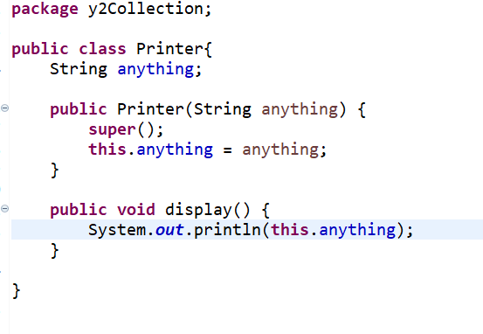
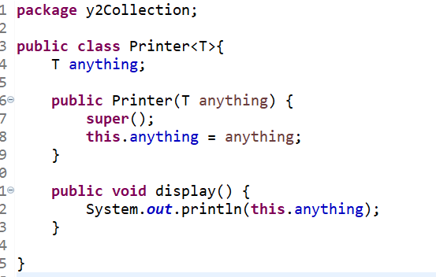

- Fill the following table of class member access modifiers(use Yes and No)

Visibility | public | protected | default | private
From the same class
From any class in the same package
From a subclass in the same package
From a subclass outside the same package
From any non subclass outside the package

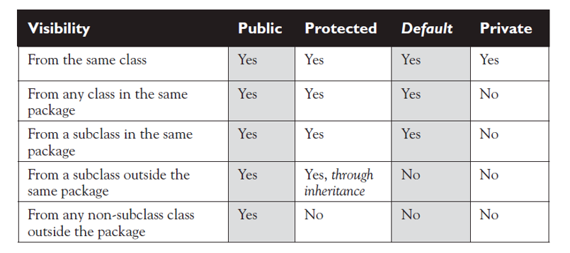
- Consider the following program, add a main function, change the price of HP to 700. Then after, use switch case to display the price of each laptop
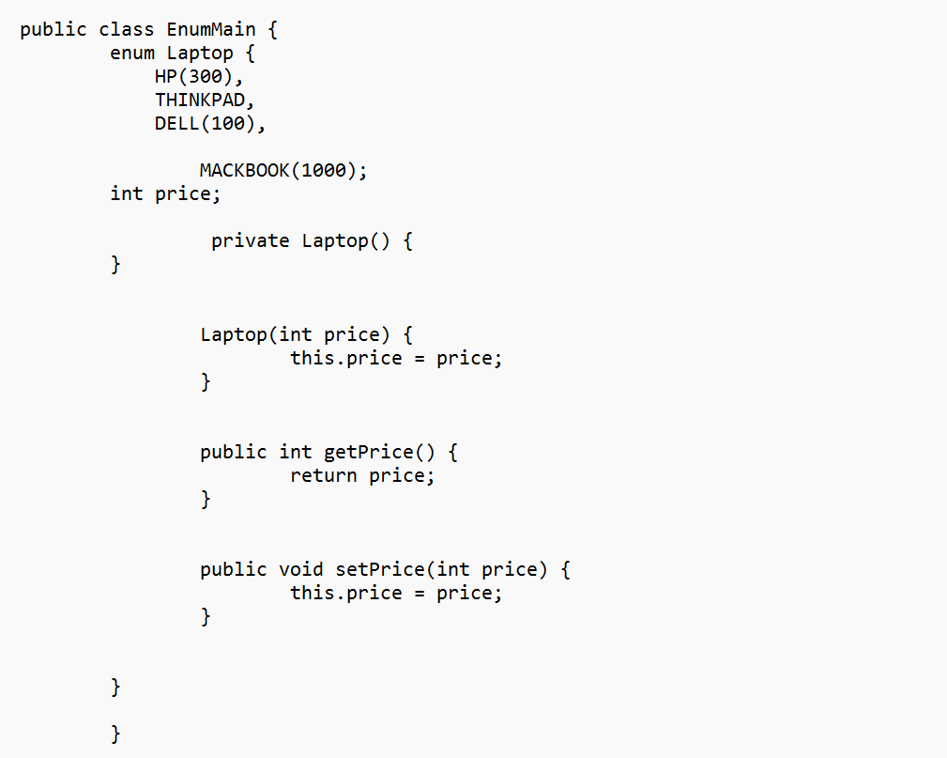
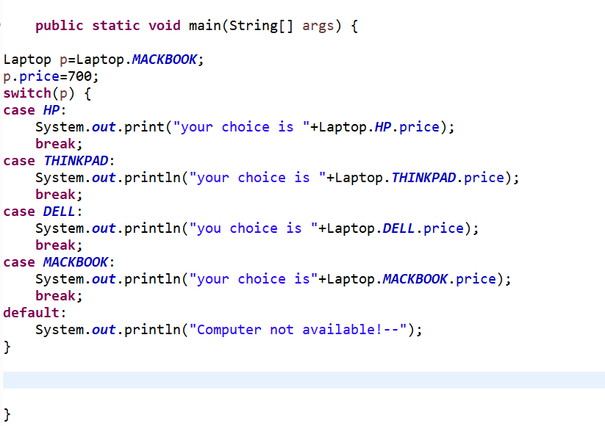
- Write a program that sorts the employees data in ascending order without duplicates. The Employee with properties lastName, firstName,position, age , salary . In your main class add the following Sample data.
Mugisha, Mike, Software Engineer, 20, 3000
Mugisha, Marc,Database Administrator, 18, 2000
Mugisha,Mike, Software Engineer, 20, 3000
Mugisha Moses, Software Developer, 20, 3000
Iradukunda Sandra, Database Administrator, 20, 3000
Iradukunda Gael, Software Engineer, 20, 3000

import java.util.ArrayList;
import java.util.Collections;
import java.util.Objects;
import java.util.TreeSet;

/*
* @Author T
*/
public class Employee implements Comparable{
private String lastName;
private String firstName;
private Integer age;
private String position;
private Integer salary;
/**
* @param lastName
* @param firstName
* @param age
* @param position
* @param salary
*/
public Employee(String lastName, String firstName, String position, int age,int salary) {
this.lastName = lastName;
this.firstName = firstName;
this.position = position;
this.age = age;
this.salary = salary;
}

@Override
public int compareTo(Object o) {
Employee emp=(Employee)o;

if( this.lastName.compareTo(emp.lastName)!=0)
return this.lastName.compareTo(emp.lastName);
if( this.firstName.compareTo(emp.firstName)!=0)
return this.firstName.compareTo(emp.firstName);
if( this.position.compareTo(emp.position)!=0)
return this.position.compareTo(emp.position);
if( this.age.compareTo(emp.age)!=0)
return this.age.compareTo(emp.age);
return this.salary.compareTo(emp.salary);
}
@Override
public String toString() {
return "Employee [lastName=" + lastName + ", firstName=" + firstName + ", age=" + age + ", position=" + position
+ ", salary=" + salary + "]";
}
}

Note: You can can add any other optional code of his/her choice apart from the provided if he/she is using it
Getters, setters, Equals and hashCode are optional if not used

Main

import java.util.ArrayList;
import java.util.Collections;
import java.util.TreeSet;
public class Programs {
public static void main(String[]args) {
//Best Option
TreeSet<Employee> emps=new TreeSet<Employee>();
emps.add(new Employee("Mugisha","Mike","Software Engineer",20,3000));
emps.add(new Employee("Mugisha","Moses","Software Developer",20,3000));
emps.add(new Employee("Mugisha","Mike","Software Engineer",20,3000));
emps.add(new Employee("Iradukunda","Sandra","Database Administrator",20,3000));
emps.add(new Employee("Iradukunda","Gael","Software Engineer",20,3000));
for(Employee emp:emps) {
System.out.println(emp);
}
//Alternative with duplication
ArrayList<Employee> ems=new ArrayList<Employee>();
ems.add(new Employee("Mugisha","Mike","Software Engineer",20,3000));
ems.add(new Employee("Mugisha","Moses","Software Developer",20,3000));
ems.add(new Employee("Mugisha","Mike","Software Engineer",20,3000));
ems.add(new Employee("Iradukunda","Sandra","Database Administrator",20,3000));
ems.add(new Employee("Iradukunda","Gael","Software Engineer",20,3000));
Collections.sort(ems);
for(Employee emp:ems) {
System.out.println(emp);
}
}
}

- List types of inheritance supported by java on the basis of class, give an example for each type
Sample Answer: On the basis of class, there can be three types of inheritance in java: single, multilevel and hierarchical
Example
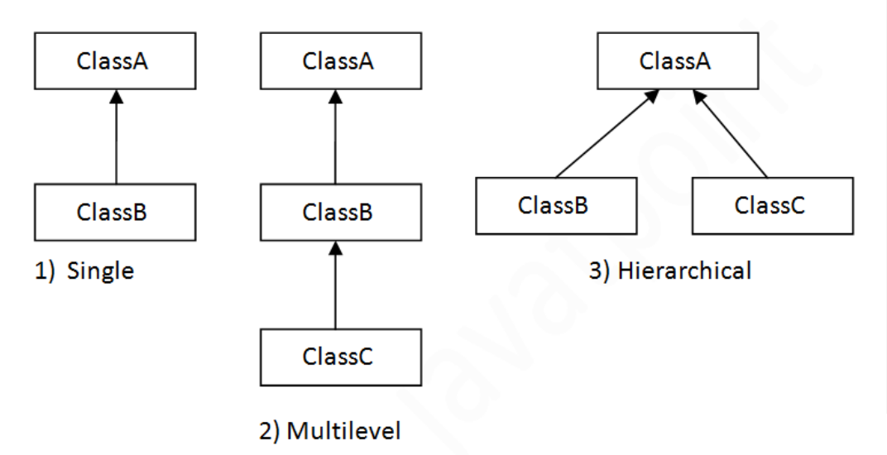
Note: You can also create the classes and respective interfaces to illustrate this
- You are tasked to develop an application that sort Books. A Book has its ISBN(String), title(String), author(String) and publication year. By implementing Comparable interface, write appropriate Book class that enable sorting the books. Books should be sorted by title first, author at the second option, publication Year and lastly by ISBN.. Write a main Program with main method to sort the following books in a collection.
Book sample data

ISBN | title | author | pubYear
12bc | Java1 | Mary | 2021
12db | Hamlet | Shakespeare | 2020
12rw | React js | John | 2022
12ck | java2 | Mary | 2017

Answer:
Book Class

class Book implements Comparable {
private String ISBN;
private String title;
private String author;
private Integer pubYear;
public Book() {
}
public Book(String iSBN, String title, String author, Integer pubYear) {
ISBN = iSBN;
this.title = title;
this.author = author;
this.pubYear = pubYear;
}
@Override
public String toString() {
return "Book [ISBN=" + ISBN + ", title=" + title + ", author=" + author + ", pubYear=" + pubYear + "]";
}
@Override
public int compareTo(Object o) {
Book book = (Book) o;
//First by title
if (this.title.compareTo(book.title) != 0)
return this.title.compareTo(book.title);
//Second by Author
if (this.author.compareTo(book.author) != 0)
return this.author.compareTo(book.author);
//Third by Publication Year
if (this.pubYear.compareTo(book.pubYear) != 0)
return this.pubYear.compareTo(book.pubYear);
//Finally by ISBN
return this.ISBN.compareTo(book.ISBN);
}
}

Main Program class

import java.util.ArrayList;
import java.util.Arrays;
import java.util.Collections;
import java.util.List;
import java.util.TreeSet;
public class Main {
public static void main(String[] args) {
// using TreeSet
TreeSet<Book> books = new TreeSet<Book>();
Book b1 = new Book("12bc", "Java1", "Mary", 2021);
Book b2 = new Book("12db", "Hamlet", "Shakespeare", 2020);
Book b3 = new Book("12rw", "React js", "John", 2022);
Book b4 = new Book("12ck", "Java2", "Mary", 2017);
books.add(b1);
books.add(b2);
books.add(b3);
books.add(b4);
// Books are sorted as they are in TreeSet
for (Book b : books) {
System.out.println(b);
}
}
}

OUTPUT:
Book [ISBN=12db, title=Hamlet, author=Shakespeare, pubYear=2020]
Book [ISBN=12bc, title=Java1, author=Mary, pubYear=2021]
Book [ISBN=12ck, title=Java2, author=Mary, pubYear=2017]
Book [ISBN=12rw, title=React js, author=John, pubYear=2022]

Another Alternative Main class

import java.util.ArrayList;
import java.util.Arrays;
import java.util.Collections;
import java.util.List;
import java.util.TreeSet;
public class Main {
public static void main(String[] args) {
// Method using ArrayList
List<Book> bks = new ArrayList<Book>();
bks.add(b1);
bks.add(b2);
bks.add(b3);
bks.add(b4);
System.out.println("Before sorting");
for (Book b : bks) {
System.out.println(b);
}
// Sorting using Collections
Collections.sort(bks);
System.out.println("After sorting");
for (Book b : bks) {
System.out.println(b);
}
}
}

OUTPUT

Before sorting

Book [ISBN=12bc, title=Java1, author=Mary, pubYear=2021]
Book [ISBN=12db, title=Hamlet, author=Shakespeare, pubYear=2020]
Book [ISBN=12rw, title=React js, author=John, pubYear=2022]
Book [ISBN=12ck, title=Java2, author=Mary, pubYear=2017]

After sorting

Book [ISBN=12db, title=Hamlet, author=Shakespeare, pubYear=2020]
Book [ISBN=12bc, title=Java1, author=Mary, pubYear=2021]
Book [ISBN=12ck, title=Java2, author=Mary, pubYear=2017]
Book [ISBN=12rw, title=React js, author=John, pubYear=2022]

- Using BufferedReader, write a program that read the entire line of text in a file named input.txt and write the line in output.txt. The content of both file at the end should be the same. Assume the file are in root directory and no need to add a path.

Sample file(input.txt)
0101, Nyarugenge,01,Kigali City
0102,Gasabo,01,Kigali City
0103,Kicukiro,01,Kigali City

Sample Answer
public class CopyLines {
public static void main(String[] args) throws IOException {
BufferedReader inputStream = null;
PrintWriter outputStream = null;
try {
inputStream = new BufferedReader(new FileReader("input.txt"));
outputStream = new PrintWriter(new FileWriter("output.txt"));
String line
while ((line = inputStream.readLine()) != null) {
outputStream.println(line);
}
} finally {
if (inputStream != null) {
inputStream.close();
}
if (outputStream != null) {
outputStream.close();
}
}
}
}

- List and explain any 3 JDBC query executor methods
Sample Answer:
Commonly used Statement Interface methods are listed below:

Method Name | Description
boolean execute(String sql) | It is used to execute the given SQL statement, which may return multiple results.  It will return Boolean which is true if the first result is ResultSet object; false if it is an update count or there are no results.
ResultSet executeQuery(String sql) | It is used to execute SELECT SQL statement, which returns ResultSet objects.
int executeUpdate(String sql) | It is used to execute the SQL statement that returns nothing, such as an SQL DDL statement.You can use this method for INSERT, UPDATE or DELETE SQL statements It returns an int value that represents the row counts that are inserted, updated, deleted or returns 0 if nothing is returned
int[] executeBatch() | It is used to submit a batch of SQL statements for execution and if all statements are executed successfully returns the updated count in an array.

- Complete the following program to make database connection with provided details.
import java.sql.*;
class DatabaseConnection{
public static void main(String []args){
String url=”jdbc:mysql://localhost:3306/misdb” ;
String username=”root”;
String password=”code@2020”;
String driver=”com.mysql.cj.jdbc.Driver”;
String query=“Select * from students”;
try{
Class.forName(.........);
Connection con=DriverManager.getConnection(……………………….);
Statement st = con.createStatement();
int count = st.executeUpdate(..........);
System.out.println("number of students is= "+ count);

con.close();
}catch(Exception e){
System.out.println(e);}
}
}
Answer:
import java.sql.*;
class DatabaseConnection{
public static void main(String []args){
String url=”jdbc:mysql://localhost:3306/misdb” ;
String username=”root”;
String password=”code@2020”;
String driver=”com.mysql.cj.jdbc.Driver”;
String query=“Select * from students”;
try{
Class.forName(driver);
Connection con=DriverManager.getConnection(url,username,password);
Statement st = con.createStatement();
int count = st.executeUpdate(..........);
System.out.println("number of students is= "+ count);
con.close();
}catch(Exception e){
System.out.println(e);}
}
}

- Consider the entity Employee(id,firstname,lastname, email, nationalIdentity, age) and EmployeeRepository.
  - Using JPQL, determine a method to findEmployeeByNationalIdentity(double nationalIdentity) in employee repository.
Answer:
public interface EmployeeRepository extends JpaRepository<Employee, Integer> {
@Query("SELECT s from Employee e WHERE e. nationalIdentity=?1")
Employee findEmployeeByNationalIdentity (double nationalIdentity);
- Using SQL native query, write a method findByAgeBetween(int age1, int age2) .
Answer:
@Query(value="SELECT * FROM employee WHERE age BETWEEN :age1 AND :age2",nativeQuery=true)
List<Employee> findByAgeBetweenAge(int ag1, int age2);

- Explain a singleton design pattern? Implement the singleton design pattern using a provided class StudentService. Add a Program class with the main method to create the StudentService object.
Answer:
The singleton pattern provides a way to limit the instances of a class to one
We create a global point of access to it.
Create a private constructor and a public static method to access its instance. This allows us to coordinate use of the class across the whole application
class StudentService {
private static StudentService onlyOneInstance;
private StudentService() {}
public static StudentService getInstance() {
if (onlyOneInstance == null)
onlyOneInstance = new StudentService();
return onlyOneInstance;
}
public void doSomething(){
}
}
public class Main{
public static void main(String [] args){
StudentService s=StudentService.getInstance();
s.doSomething();
}
}
Alternative StudentService class
class StudentService {
private static StudentService onlyOneInstance=new StudentService();
private StudentService() {}
public static StudentService getInstance() {
return onlyOneInstance;
}
public void doSomething(){
}
}

- Consider the following codes, give the output for each statement.

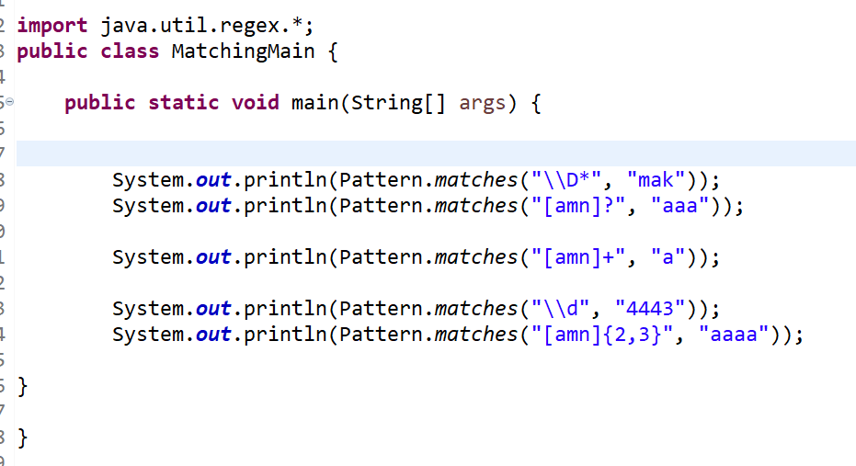
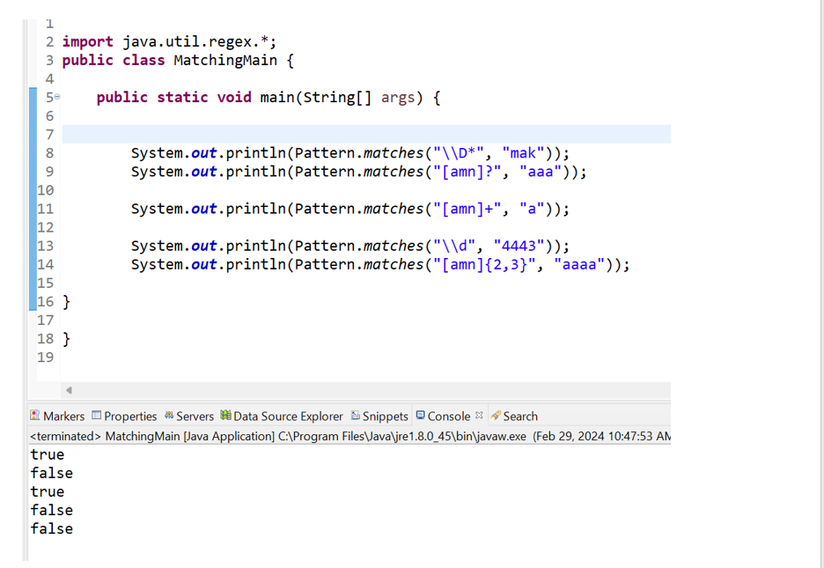

- We have two JSP files, Welcome.jsp and display.jps. Welcome file is used to help the user to enter the first name and last name. we are collecting the entered values on display file by using scriptlet. Write the equivalent by using expression language to display first name and last name values entered by the user on the welcome page.

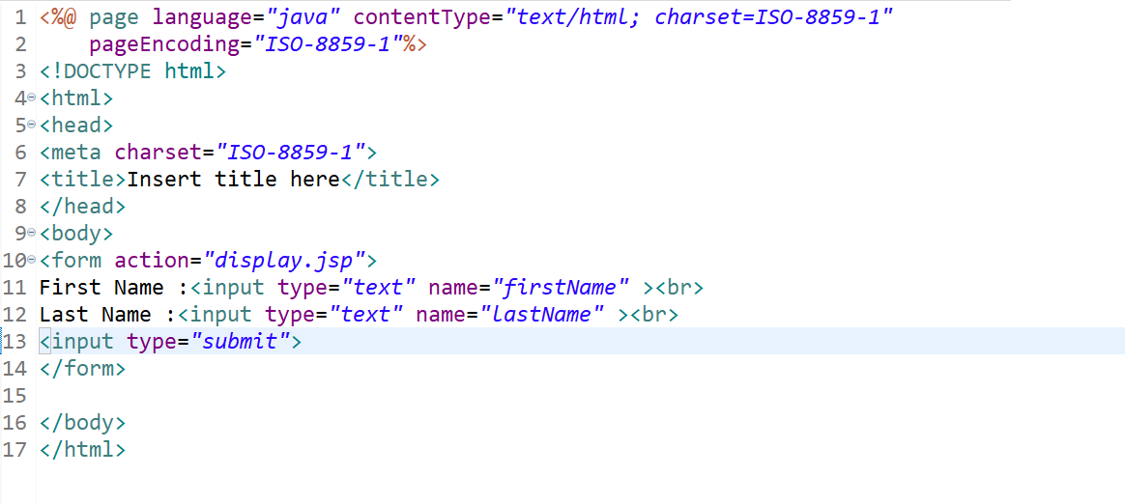
Welcome.jsp
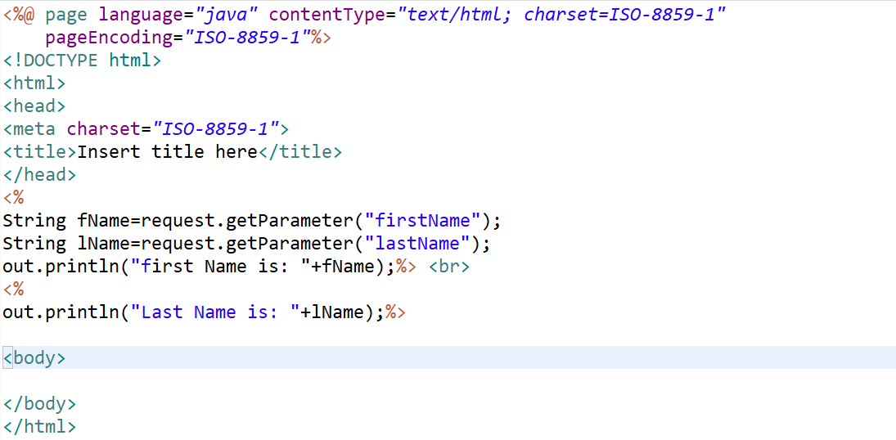
display.jsp

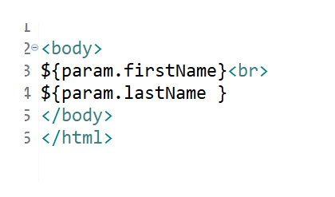

- Discuss 2 similarities and 2 differences between abstract class and interface in java.
Similarities:
- Both facilitate abstraction: Both classes and interfaces help in achieving abstraction, which is one of the fundamental principles of object-oriented programming. Abstraction allows developers to focus on the essential features of an object while hiding the unnecessary details.
- Both support inheritance: Both classes and interfaces support inheritance, allowing one class or interface to inherit the attributes and methods of another. This promotes code reusability and enables the creation of hierarchies of related objects.
- Both can declare methods : Both classes and interfaces can declare methods that define the behavior of objects. Methods declared in interfaces do not have implementations (prior to Java 8), while methods in classes can have implementations.
Differences:
- Implementation:
  - Classes can contain both method declarations and method implementations.
  - Interfaces, on the other hand, can only declare method signatures without providing implementations (except for default methods introduced in Java 8 and static methods introduced in Java 8).
- Multiple inheritance:
  - Java classes do not support multiple inheritance, meaning a class can only extend one other class. This is to prevent the diamond problem and maintain a clear and understandable class hierarchy.
  - Java interfaces, however, support multiple inheritance, meaning an interface can extend multiple other interfaces. This allows a class to implement multiple interfaces, inheriting method signatures from each of them.
- Instantiation:
  - Objects of classes can be instantiated using the new keyword. These objects can then be used to invoke the methods defined within the class.
  - Interfaces cannot be instantiated directly. They are implemented by classes, and objects of these classes can be instantiated. However, interfaces can be referenced polymorphically using their reference types.
- Access Modifiers:
  - In classes, methods and variables can have different access modifiers (public, private, protected, default) controlling their visibility and accessibility.
  - In interfaces, all methods are by default assumed to be public and abstract (prior to Java 8). However, since Java 8, interfaces can also have default and static methods, which can have implementations and can specify access modifiers.
- Variables:
  - Classes can have instance variables and class (static) variables.
  - Interfaces can have only constant variables (variables declared with the final keyword), which are implicitly public, static, and final.
In summary, classes are used to define objects with attributes and behaviors, and they support both inheritance and encapsulation. Interfaces are used to define contracts for classes, promoting code interoperability and multiple inheritance. Both are essential in Java programming but serve different roles and have different capabilities.

- By using examples, differentiate abstraction from encapsulation in java.

Sample Answer
- Encapsulation is data hiding(information hiding) while Abstraction is detailed hiding(implementation hiding).
- While encapsulation groups together data and methods that act upon the data, data abstraction deal with exposing the interface to the user and hiding the details of implementation.
- Encapsulated classes are Java classes that follow data hiding and abstraction We can implement abstraction by using abstract classes and interfaces.
- Encapsulation is a procedure that takes place at the implementation level, while abstraction is a design-level process.
Encapsulation: A class with private property(ies) and setters and getters
Abstraction: An abstract class or interface( may be with extending/implementing classes)

More detailed

Encapsulation is about concealing the functionality of a class from other classes
A class should provide an interface of public methods which other classes can call to manipulate that classes data
This means that the functionality of a class can be changed without breaking the entire program
We can modify a class without changing how other classes interact with it
We can make a field read-only by only providing a getter
We can protect our class from invalid values by checking values in the setter, e.g.
Abstraction
Abstraction in Java is an important concept that every Java Developer should understand to build robust and efficient software. In simple terms, Abstraction is the process of hiding the implementation details or irrelevant details and showing only the necessary information to the user. One of the most fundamental concepts in Java is Abstraction. This technique is used to simplify the complexity of a program by providing a simpler view of the system. Abstraction in Java is the process of hiding an application's inner workings from the outside world
Data Abstraction may also be defined as the process of identifying only the required characteristics of an object ignoring the irrelevant details. The properties and behaviors of an object differentiate it from other objects of similar type and also help in classifying/grouping the objects

In Java, abstraction is achieved by interfaces and abstract classes. We can achieve 100% abstraction using interfaces.
Achieving abstraction:
Java provides both Abstract classes and Interfaces to achieve Data Abstraction. Interfaces allow for complete Abstraction and maximum flexibility. It means that the implementation details are entirely hidden and abstracted from the user interface, and this approach permits maximum reusability and flexibility.
Abstract classes in Java offer partial to complete Abstraction. It can contain both concrete methods (with implementation) and abstract methods (without implementation). This approach can be helpful in scenarios where some implementation details can be shared among different subclasses.

- Explain upcasting and downcasting in java , give examples to support your explanations .
Upcasting
Casting a child object to a parent object(implicit casting and explicit casting) or casting of small to big object
Examples
short big = 5646;
int bigger = big;
long biggest = bigger;

downcasting
Casting a parent object to a child object(Explicit casting) or casting of big to small object
Examples :
long big = 3453;
int notSoBig2 = (int)big;
short smaller = (short)big;
Examples with Classes

public class Person{}
public class Student extends Person{}

public class Program{
public static void main(String [] argos)
{
Person p1=new Student(); //Upcasting
Student s1=(Student) p1; /// DownCasting

General Questions(mixed)

- Consider the two classes below and solve the provided questions. By using student and laptop classes, one student may own many laptops. The laptop has a student mapped to it and a student class has a list of all Laptops. By using appropriate annotations, make the two classes persistent entities.Fields should not allow null values. The characters of String should not exceed 100.Make email field unique . Rewrite classes to put a relationship between them.Use eager fetching

public class Student{
private int id;
private String firstName;
private String lastName;
private String email;
private Laptop laptop
}
public class Laptop{
private int lapId;
private String brand;
}
Sample Answer:
import jakarta.persistence.*;
import jakarta.validation.constraints.Email;
import jakarta.validation.constraints.NotNull;
import jakarta.validation.constraints.Size;
import java.util.List;

@Entity
@Table(name = "students")
public class Student {

@Id
@GeneratedValue(strategy = GenerationType.IDENTITY)
private int id;

@NotNull
@Size(max = 100)
private String firstName;

@NotNull
@Size(max = 100)
@Column(name=”fname”, length=100, nullable=false)
private String lastName;

@NotNull
@Email
@Column(unique = true,name=”email”, length=100, nullable=false))
@Size(max = 100)
private String email;

@OneToMany(mappedBy = "student", fetch = FetchType.EAGER, cascade = CascadeType.ALL)
private List<Laptop> laptops;

// Getters and Setters
public int getId() {
return id;
}

public void setId(int id) {
this.id = id;
}

public String getFirstName() {
return firstName;
}

public void setFirstName(String firstName) {
this.firstName = firstName;
}

public String getLastName() {
return lastName;
}

public void setLastName(String lastName) {
this.lastName = lastName;
}

public String getEmail() {
return email;
}

public void setEmail(String email) {
this.email = email;
}

public List<Laptop> getLaptops() {
return laptops;
}

public void setLaptops(List<Laptop> laptops) {
this.laptops = laptops;
}
}
@Entity
public class Laptop {
@Id
@GeneratedValue
private int lapId;
@Column(nullable = false, length = 100)
private String brand;
@ManyToOne(fetch = FetchType.EAGER)
@JoinColumn(name = "student_id", nullable = false)
private Student student;
public Laptop() {
}
public Laptop(String brand, Student student) {
super();
this.brand = brand;
this.student = student;
}
public int getLapId() {
return lapId;
}
public void setLapId(int lapId) {
this.lapId = lapId;
}
public String getBrand() {
return brand;
}
public void setBrand(String brand) {
this.brand = brand;
}
public Student getStudent() {
return student;
}
public void setStudent(Student student) {
this.student = student;
}
}

- In the context of Spring Data JPA, the JpaRepository interface provides a variety of methods for performing CRUD operations and other database interactions. List 5 possible methods that JpaRepository offers and briefly describe the purpose of each method.
Sample Answer:
save(S entity):
  - Purpose: Saves a given entity. If the entity is new, it creates it; otherwise, it updates the existing entity.
saveAll(Iterable<S> entities):
  - Purpose: Saves all given entities.
fi ndById(ID id):
  - Purpose: Retrieves an entity by its id.
existsById(ID id):
  - Purpose: Checks whether an entity with the given id exists.
findAll():
  - Purpose: Returns all entities.
findAllById(Iterable<ID> ids):
  - Purpose: Returns all entities with the given ids.
count():
  - Purpose: Returns the number of entities.
deleteById(ID id):
  - Purpose: Deletes the entity with the given id.
delete(T entity):
  - Purpose: Deletes a given entity.
deleteAll(Iterable<? extends T> entities):
  - Purpose: Deletes the given entities.
deleteAll():
  - Purpose: Deletes all entities managed by the repository.
flush():
  - Purpose: Flushes all pending changes to the database.
saveAndFlush(S entity):
Purpose: Saves an entity and flushes changes immediately.
deleteInBatch(Iterable<T> entities):
  - Purpose: Deletes the given entities in a batch, using a single query.
deleteAllInBatch():
  - Purpose: Deletes all entities in a batch, using a single query.
getOne(ID id):
  - Purpose: Retrieves an entity by its id, but does not trigger a database query until the entity is accessed (also known as a lazy fetch).
findAll(Sort sort):
  - Purpose: Returns all entities sorted according to the provided sort parameter.
findAll(Pageable pageable):
  - Purpose: Returns a paginated list of entities.
Custom Query Methods
In addition to these methods, you can define custom query methods by following the naming conventions defined by Spring Data JPA. For example:
- findByPropertyName(PropertyType property):
  - Purpose: Finds entities based on a given property value.
- findTopByOrderByPropertyDesc():
  - Purpose: Finds the top entity ordered by a property in descending order.
Others in a repository
import org.springframework.data.jpa.repository.JpaRepository;
import org.springframework.data.jpa.repository.Query;
import org.springframework.data.repository.query.Param;

import java.util.List;
@Repository
public interface StudentRepository extends JpaRepository<Student, Integer> {

// 1. Find students by last name
@Query("SELECT s FROM Student s WHERE s.lastName = :lastName")
List<Student> findByLastName(@Param("lastName") String lastName);

// 2. Find students by first name
@Query("SELECT s FROM Student s WHERE s.firstName = :firstName")
List<Student> findByFirstName(@Param("firstName") String firstName);

// 3. Find students by email
@Query("SELECT s FROM Student s WHERE s.email = :email")
Student findByEmail(@Param("email") String email);

// 4. Find students with a specific laptop brand
@Query("SELECT s FROM Student s WHERE s.laptop.brand = :brand")
List<Student> findByLaptopBrand(@Param("brand") String brand);

// 5. Find students whose first name starts with a specific prefix
@Query("SELECT s FROM Student s WHERE s.firstName LIKE :prefix%")
List<Student> findByFirstNameStartingWith(@Param("prefix") String prefix);
}

